How to Sign Up for the Fujitsu Toolbox
- Go to fujitsugeneral.com; Click “For Your Home or Small Business”
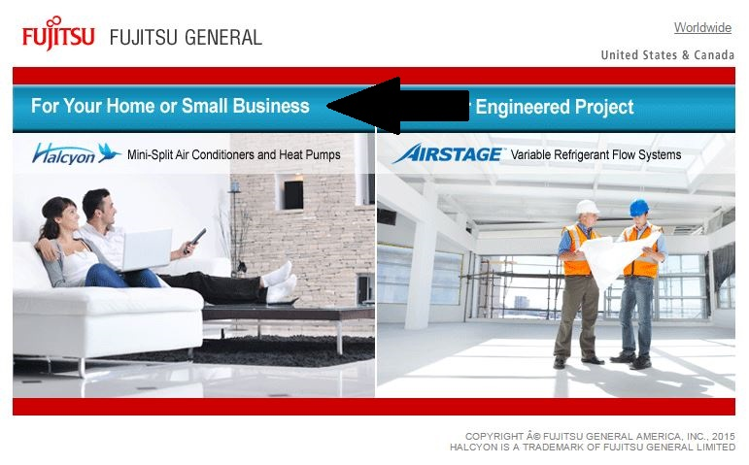
- Click on “Fujitsu Toolbox”
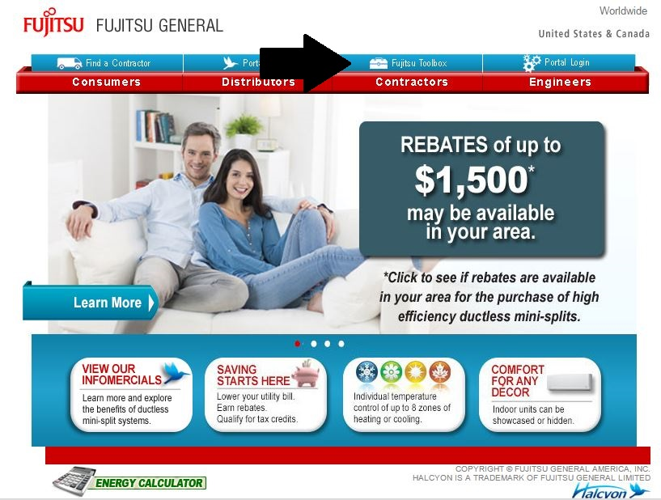
- Click “Register Now”
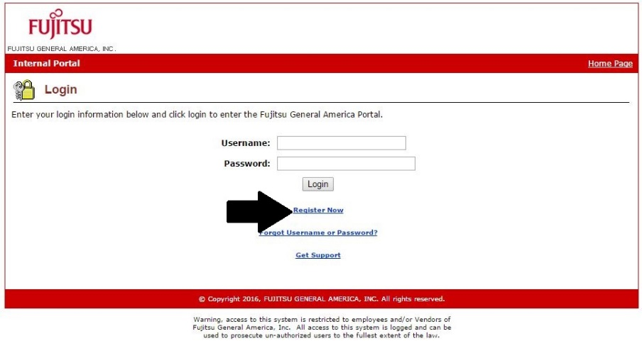

- Select the type of account (I.e. Contractor)
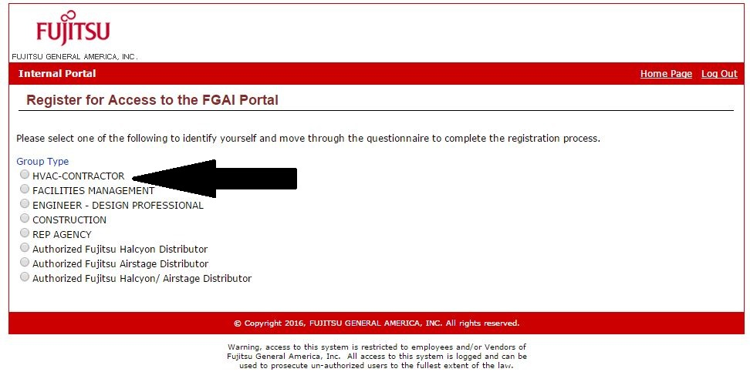
- Follow the links
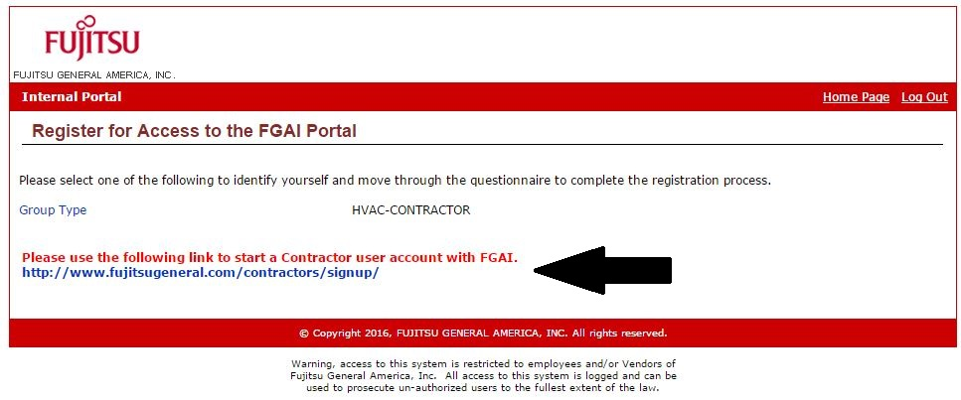
- Fill out your information; Click “Submit”
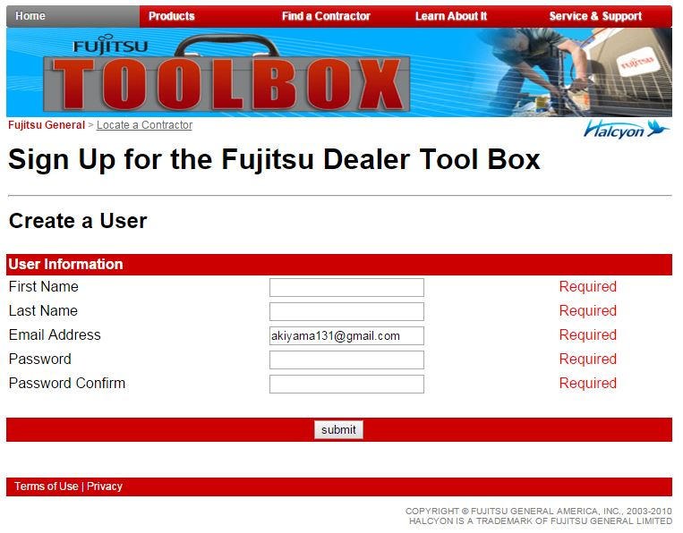
- If your company exists click the company & Click “Submit”(IF YOU COMPANY DOES NOT EXIST PROCEED TO STEP 9)
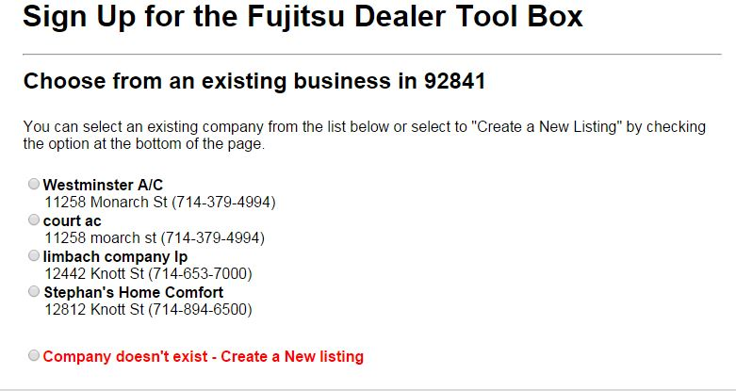
- You will then get a confirmation. Please go to your email and validate the account.
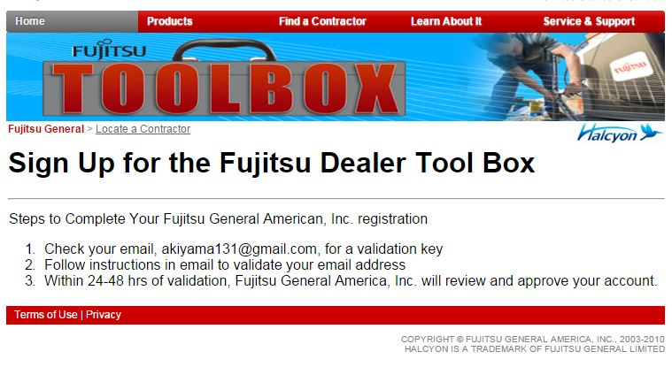
- If you do not see your company listed, please click “Company doesn’t exist – Create a New Listing”
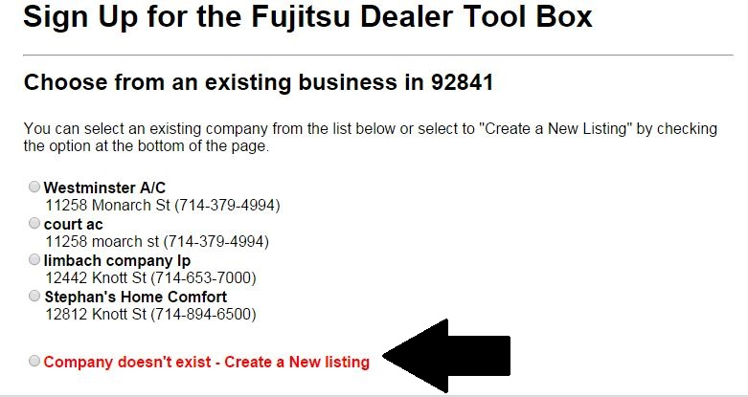
- Fill out your company information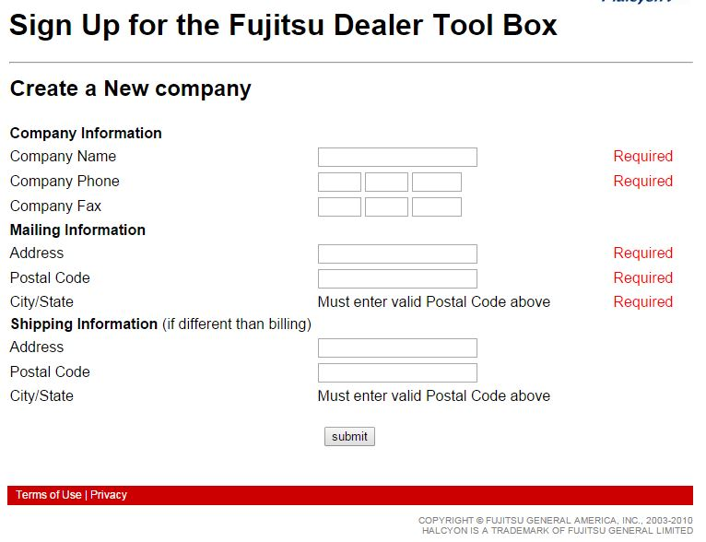
- You will then get a confirmation. Please go to your email and validate the account.
- If someone at your company already has a toolbox account, you can ask them to sign you up: Click “Contractor Tools”
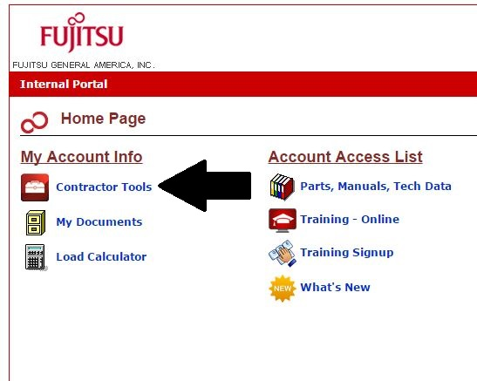
- Click “Add User”
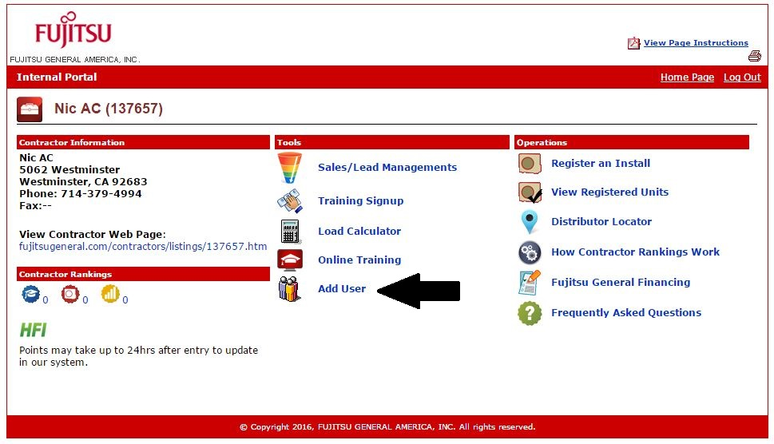
- A Pop up window will appear. Click “OK”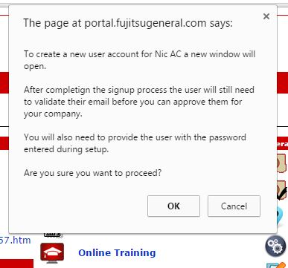
- Fill out the form for user:
- Confirm the company
- Confirmation will come up. Please validate account from the Fujitsu email.

