How to Register Installations
- Login to the toolbox. https://portal.fujitsugeneral.com/login/index.cfm?SERVER_NAME=dealers.fujitsugeneral.com
- Click “Contractor Tools”
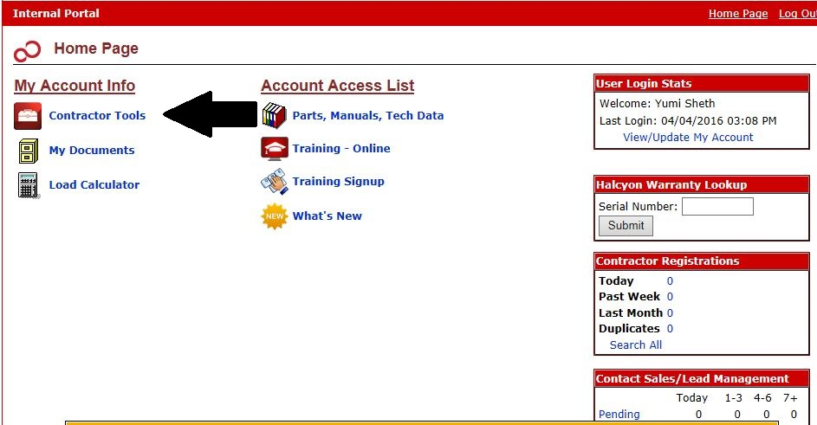
- Click “Register an Install”
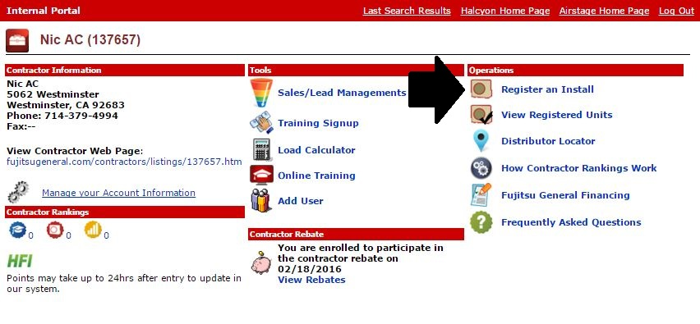
- Accept the terms
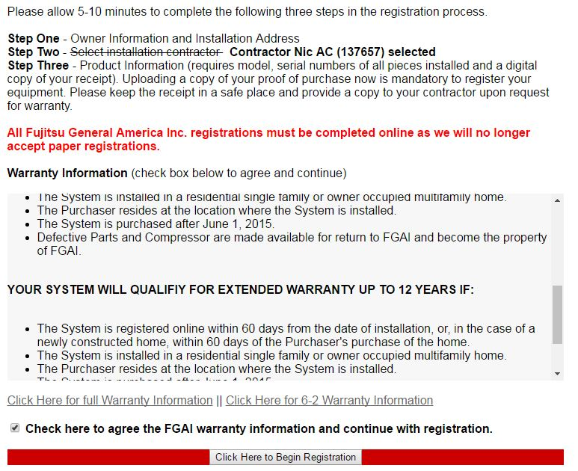
- Fill out the form
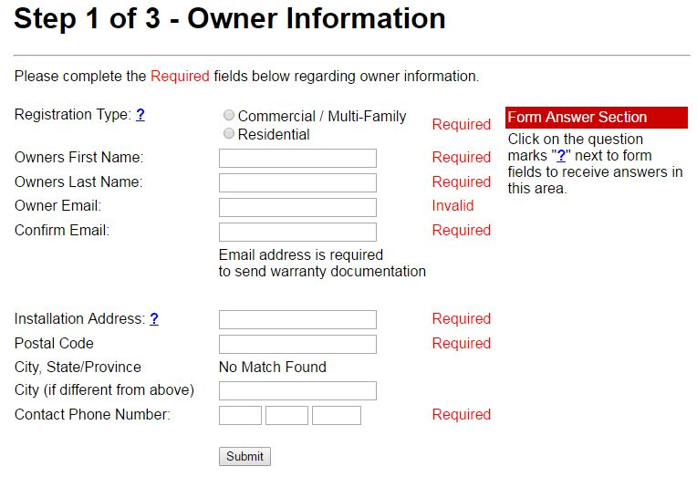
- Step 2 will be skipped if you are registering from your toolbox (contractor) account. The homeowner will see this page. If they do not see your company listed they can type in your company name and address.
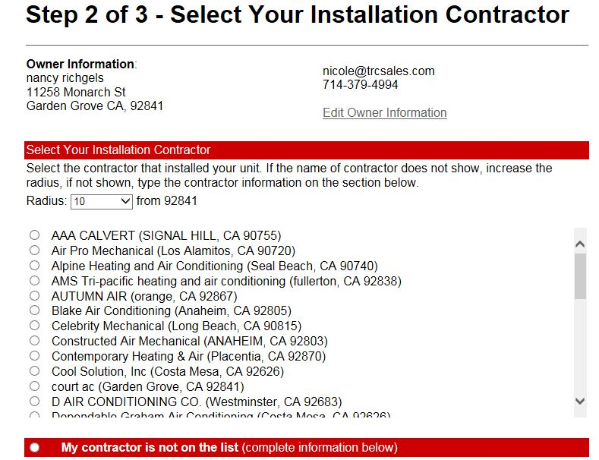

- Fill out the installation information. 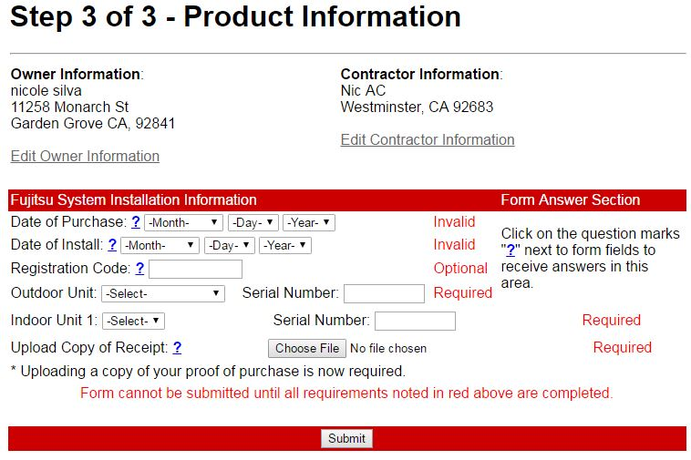
- If your homeowner also registers the equipment you will get this screen. Please click duplicate if you are sure you typed in the information correctly please click “Duplicate Info”. 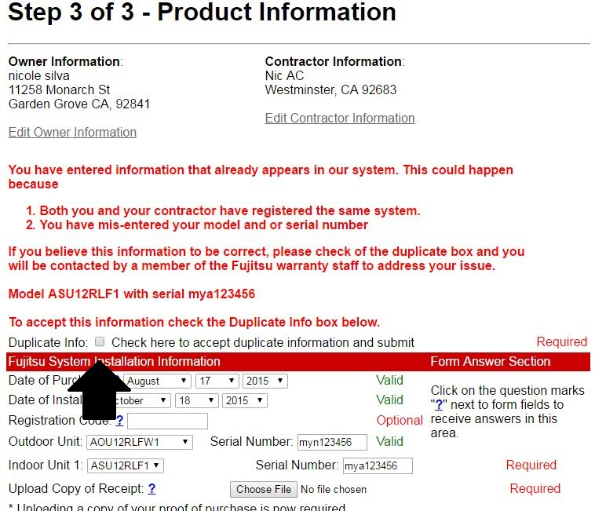
- You will see this screen next. Your customer will get a copy of the warranty certificate. Also you can see your registrations under your toolbox account. 